Ejercice 4 Create the snapshots like in the picture below using one of the virtual machines created in the previous exercises. Before each snapshot, you must change something in the operating system. This tool is normally used when performing a critical action or installing software. But, in this case, you can do something so easy as creating a new file to study the different states.

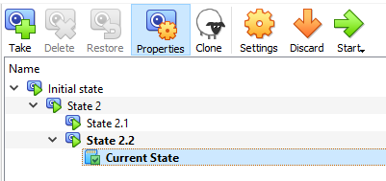
Then, complete the following actions in order:
- Restore State 2
- Delete State 2.1 and explain what happens
- Restore State 2.2
- Delete State 2.2 and explain what happens

First part: We are going to create the snapshots. For each new snapshots we will create a file to check the difference between snapshots.
We create the snapshot "Initial state" with “Tomar “of the “estado actual” and then the file" File 1.txt "in Windows.
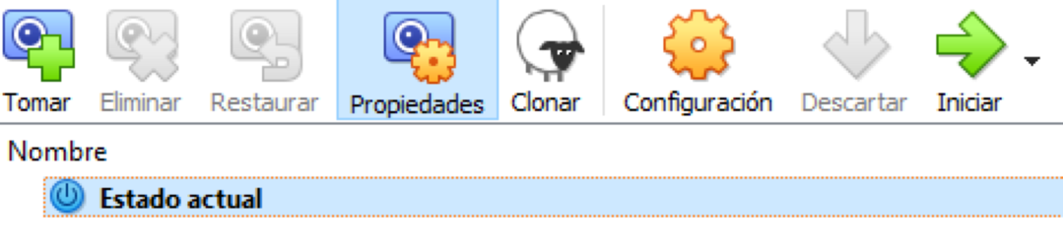
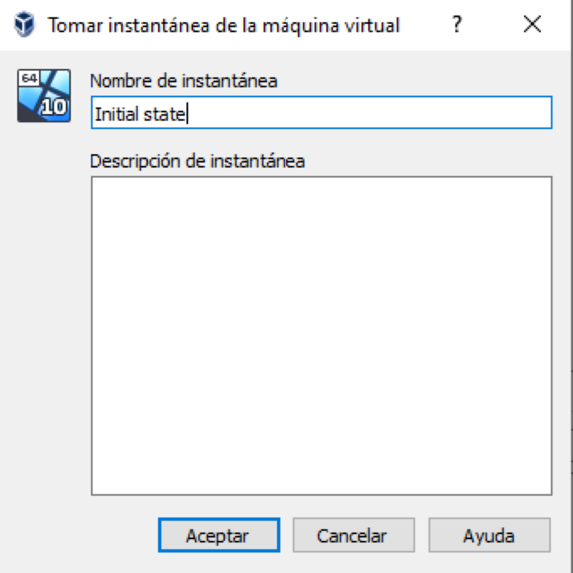

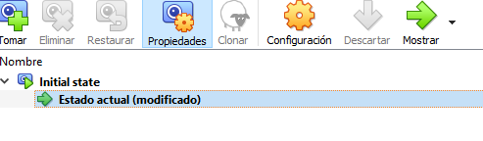
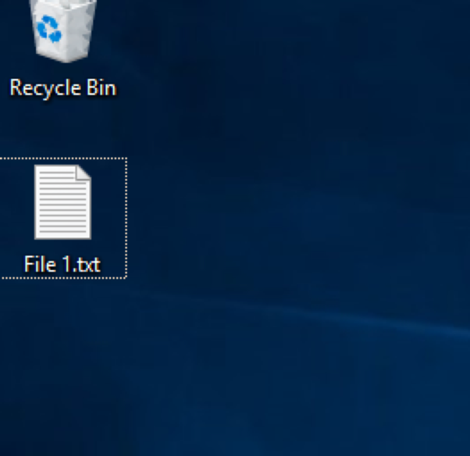

We create the snapshot "State 2”, “State 2.1” and “State 2.2” and in Windows we create the files File2.txt files File 2.1.txt and File 2.2.txt with the same process.
With the following result.
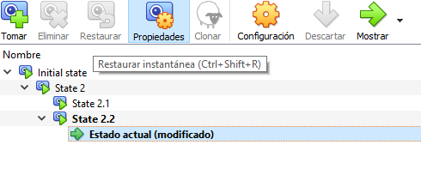
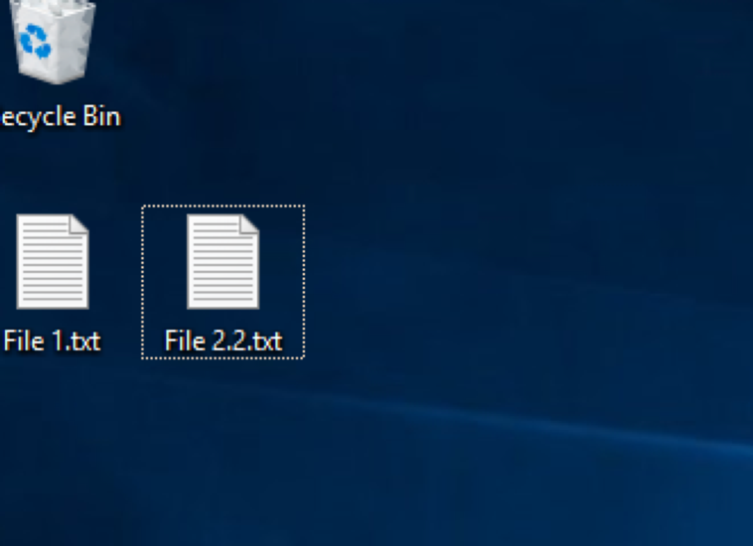

We continue with the exercise
Now we shut down the virtual machine.
After Right-click on “State 2” and “Restaurar”.
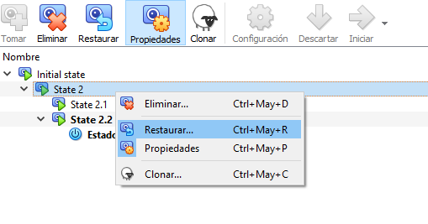
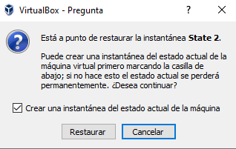

We can uncheck the checkbox “Crear una instantánea del estado actual de la máquina” (we do not need a backup of the current state).
We start the virtual machine and see that there are the File1.txt and File 2.txt files that we created, but not the File2.1.txt and File2.2 txt.
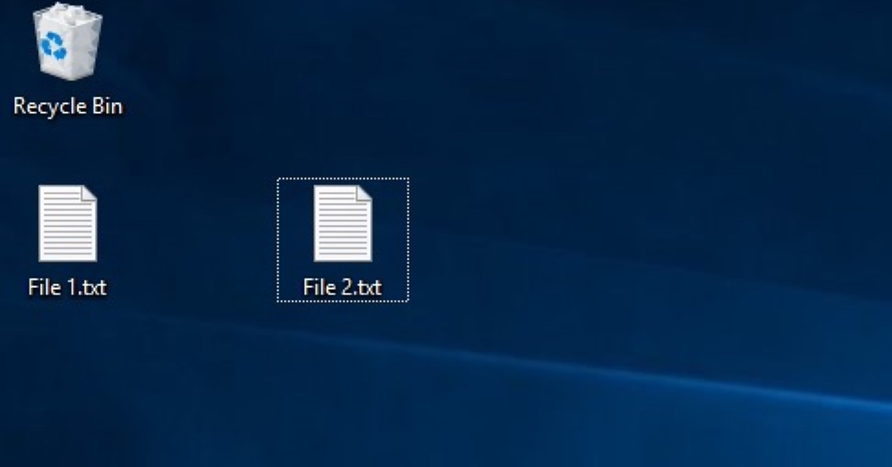

Now we restaurate State 2.2

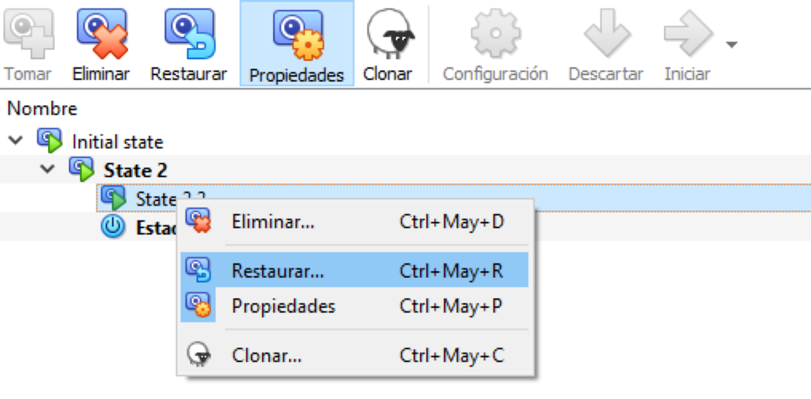
Now we delete State 2.2
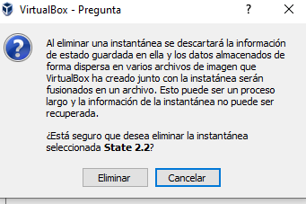

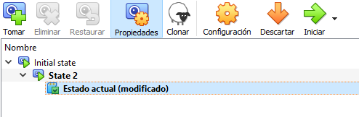

We start the virtual machine and see that there are the File1.txt, File 2.txt files that we created, and File2.2 txt., but not the File2.1.txt

